Assignment 3 - Data 1204

## About the notebook

In this notebook we will test the following hypothesis:

$$H_{0}:mean of sales with Ad2 is equal to the mean of sales with Ad1.$$

The process followed to determine if the null hypothesis is true is described in the word document. We will be carrying out a One Sample t-test. Hence, first the distribution of the sample data needs to checked: it should approximately normal.

## Preparing the Environment and Loading Data

Install required packages.

# install.packages(c("lattice", "readr", "readxl"))

Loading the required libraries.

library(lattice)  
library(readxl)  
library(readr)  
  
options(digits=3)

Loading Ad2 sales data.

sales_data <- read_excel("adanalysis.xlsx")  
sales_data

## # A tibble: 15 x 1  
## adtype2  
## <dbl>  
## 1 34170  
## 2 41990  
## 3 53890  
## 4 36380  
## 5 31960  
## 6 40120  
## 7 36890  
## 8 42840  
## 9 35360  
## 10 54400  
## 11 32470  
## 12 49980  
## 13 56950  
## 14 34170  
## 15 47430

## View the Distribution of Data

To use the One Sample t-test, we need to ensure the assumptions made for test are valid. One of the assumptions is that the distribution of the sample data should approximately normal.

hist(sales_data$adtype2, freq=F, main="Apple's Weekly Sales Data of Fifteen Weeks for Ad2", xlab='Weekly Sales of "Apple Pro 11"', breaks=10)   
lines(density(sales_data$adtype2), col="blue")

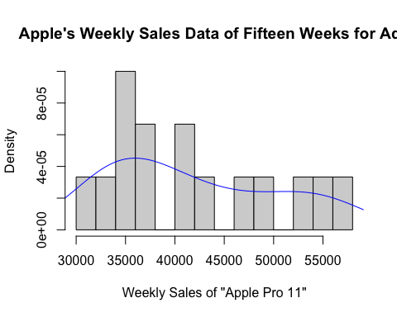

summary(sales_data)

## adtype2   
## Min. :31960   
## 1st Qu.:34765   
## Median :40120   
## Mean :41933   
## 3rd Qu.:48705   
## Max. :56950

## One Sample t-test

A simple package and method allows us to do the One Sample t-test with one line of code. The mean we are testing

t.test(sales_data, mu=30000, alternative = "two.sided")

##   
## One Sample t-test  
##   
## data: sales_data  
## t = 5, df = 14, p-value = 1e-04  
## alternative hypothesis: true mean is not equal to 30000  
## 95 percent confidence interval:  
## 37179 46688  
## sample estimates:  
## mean of x   
## 41933

## One Line Conclusion

**As it can be seen above, the p-value is significant and the null hypothesis can be rejected.**